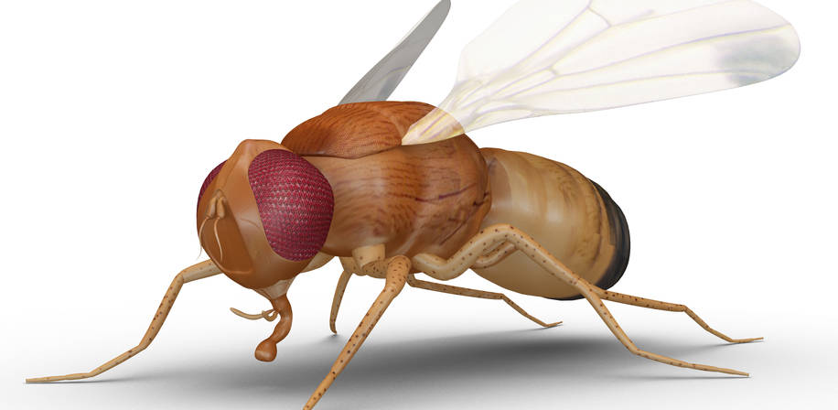
NOVA PhD-course
Invasive pest threats in the North
Course dates and location: 25-29 Sept. 2017 at the Viikki campus, University of Helsinki, Finland.
https://www.helsinki.fi/en/viikki-campus
NOVA PhD course series "Climate Change Entomology in the North", scheduled for 2017-2019.
Course Description
The series "Climate Change Entomology in the North" focuses on the fundamental and drastic demands in agricultural entomology in the Nordic countries, caused primarily by climate change. At an accelerating rate new serious, invasive pests threaten our primary production systems in agriculture, horticulture, forestry, and wilderness areas. Furthermore, our pollination and biocontrol ecosystems services - vital to our crop production as well as wild flowers and berries - are at risk due to invading pests, competitors, and diseases; changing phenology of flowering; multiple generations of pests; decline and even forecast extinctions of certain pollinator species, etc. We need to train a new generation of experts in this area to be able to cope with the growing challenges.
Content
For a full course description, please see NOVA University Network website: https://www.nmbu.no/en/students/nova/students/phd-courses/phd-2017/node/29906
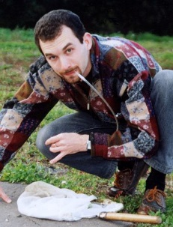
Credits: 3 ECTS
Teachers: main teachers include
- Dmitry Musolin, Saint Petersburg State Forest Technical University, Russia
- Paul Becher, Swedish University of Agricultural Sciences, Sweden
- Aurelie Ferrer, ISARA Lyon, France
- Toke Thomas Höye, Aarhus University, Denmark
- Panu Välimäki, University of Oulu, Finland





Accommodation and meals: inexpensive visiting student accommodation is reserved. The course organizer will provide transportation, and offer lunches during the course. NOVA rules require students to arrange own funding for travel and accommodation.

Course registration: by email to course organizer, Prof. Heikki Hokkanen, University of Helsinki: heikki.hokkanen@helsinki.fi Registration deadline 15 July 2017.

